Bag your space in the press: Personalise the blue text in the template press release below to send to your local paper or news outlets.

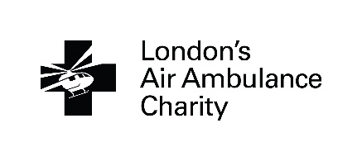
Release date: [insert date here]

Local group holds tea party to help save critically injured people in London
[or make up your own headline]

Your press release should start with details of your event – for example...

Local group [you may want to insert your names here] are holding/have held a tea party to help raise funds and awareness of London’s Air Ambulance Charity, the advanced trauma team that attend critically injured patients in London. The tea party is being/was held on [insert date] at [insert venue] as part of the charity’s ’30 years saving lives’ campaign to mark their 30th anniversary in 2019.

If you have a particular reason for supporting London’s Air Ambulance Charity and are happy to share it then it is a good idea to include this reason in this section as well.

Gareth Davies, Medical Director at London’s Air Ambulance Charity, said “On behalf of everyone here, we would like to say thank you to [you may want to insert your names here] for organising this event and helping our charity save lives. Hosting a tea party is a great opportunity not just to fundraise, but to come together as friends, families and communities to increase awareness of our vital work. It means the world to us that our core fundraising comes from the people we serve; the people of London. We’re so grateful to [you may want to insert your names here], and would love to hear from anyone inspired by them to support us.”

If you have not yet held your tea party then let people know how they can contribute, for example by contributing a prize or donating at the event. If your tea party has already been held it is a good idea to include a thank you to everyone that supported your event.

Include your contact details here if necessary.

If you are interested in joining London’s Air Ambulance Charity’s mission to save lives by holding your own tea party visit www.londonsairambulance.org.uk/teaparty, email teaparty@londonsairambulance.org.uk or call 0203 023 3319.

If your tea party has already taken place, make sure you include any fun photos and add them to the end of your press release.

Notes to editors:

London’s Air Ambulance
- London’s Air Ambulance is the charity that delivers an advanced trauma team to critically injured people in London.
- It was founded in 1989 and to date has treated over 39,000 critically injured people and attended most major incidents.
- It serves the 10 million people who live, work and travel within the M25.
- London’s Air Ambulance is a charity that operates in partnership with both Barts Health NHS Trust and the London Ambulance Service:
- Barts Health NHS Trust employs and remunerates the doctors who are seconded to the service, as well as providing some direct financial support and the helipad facility for the charity’s operations.
- London Ambulance Service similarly provide paid paramedics who are seconded to the service. An advanced trauma paramedic operates from the Service’s control room and is responsible for dispatching London’s Air Ambulance to the most critically injured people in London, 24 hours a day.

END

