Content ideas for letter to parents or carers
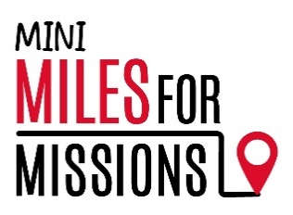
Below are some ideas for information and instructions for your Miles for Missions 2.5-mile challenge. We hope you find these helpful, but please do amend the instructions to fit your event. Thank you.
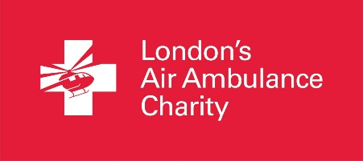

We are stepping out to support London’s Air Ambulance Charity this June!
This June we will be taking on the Mini Miles for Missions challenge and walking 2.5 miles to help support our local lifesaving air ambulance service.
By providing hospital level intervention to the side of patients as quickly as possible after injury, London’s Air Ambulance Charity aims to give the most severely injured people the best chance of survival, and best quality of life, after trauma.
An average mission cost is just under £2,500 and they rely almost entirely on donations and fundraising to fund their critical work. You can find out more about the service by visiting their interactive mission map at londonsairambulance.org.uk/our-impact/mission-map
Date: [ADD your chosen DATE and TIME here]
How we are fundraising: [Below are two examples of information for sponsorship or suggested donation that you can use or amend accordingly]
Collecting sponsorship - We are encouraging our pupils to get sponsored for their Mini Miles for Missions 2.5-mile challenge. We have supplied an official London’s Air Ambulance Charity Sponsorship Form that your child can use to record and collect sponsorship. Monies will need to be collected and paid in by [Your chosen DATE here]. Thank you for helping to support our local air ambulance charity.
Suggested donation – We are encouraging our pupils to bring in a suggested donation amount of [Your AMOUNT here] to support our Mini Miles for Missions 2.5-mile challenge to raise vital funds for London’s Air Ambulance Charity. We will be collecting donations on the same day as our challenge, on [Your chosen date here]. Thank you for helping to support our local air ambulance charity.
Details: [Please add any other details here eg PE kits, trainers, fancy dress, bottle of water etc]
Our miles will make all the all the difference to London’s Air Ambulance Charity and all seriously injured people throughout London.

