Content ideas for letter to parents or carers
Below are some ideas for information and instructions for your Miles for Missions challenge. We hope you find these helpful, but please do amend the instructions to fit your event.
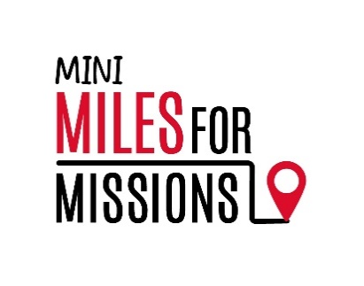
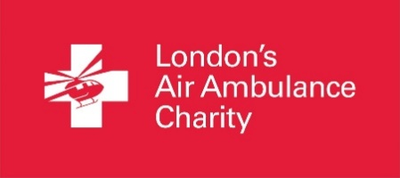

We are using our feet to fund their fleet!

We will be taking on the Mini Miles for Missions challenge to help support our local lifesaving air ambulance service on [DATE].

On average, every day five people in the city are so critically injured they need the roadside care that can only be provided by London’s Air Ambulance.

By providing specialist hospital level care to the side of patients as quickly as possible after injury, London’s Air Ambulance aims to give the most severely injured people the best chance of survival, and recovery, after trauma.

They are a charity and it costs £17 million every year to deliver the service.

You can find out more about the service by visiting their interactive mission map at londonsairambulance.org.uk/our-impact/mission-map

Date: [ADD your chosen DATE and TIME here]

How we are fundraising: [Below are two examples of information for sponsorship or suggested donation that you can use or amend accordingly]

Collecting sponsorship - We are encouraging our pupils to get sponsored for their Mini Miles for Missions challenge. We have supplied an official London’s Air Ambulance Charity Sponsorship Form that your child can use to record and collect sponsorship. Monies will need to be collected and paid in by [Your chosen DATE here]. Thank you for helping to support our local air ambulance charity.

Suggested donation – We are encouraging our pupils to bring in a suggested donation amount of [Your AMOUNT here] to support our Mini Miles for Missions challenge to raise vital funds for London’s Air Ambulance Charity. We will be collecting donations on the same day as our challenge, on [Your chosen date here]. Thank you for helping to support our local air ambulance charity.

Details: [Please add any other details here eg PE kits, trainers, fancy dress, bottle of water etc]
Our miles will help ensure that London’s Air Ambulance can continue to be there for everyone who lives, studies, works and travels in London every day.

Thank you.

